WEB AND MOBILE PROGRAMMING

ICP-1

**Web and Mobile Programming ICP-1**

Name: Madhu Varma Rudraraju

1.Installed the webstrom

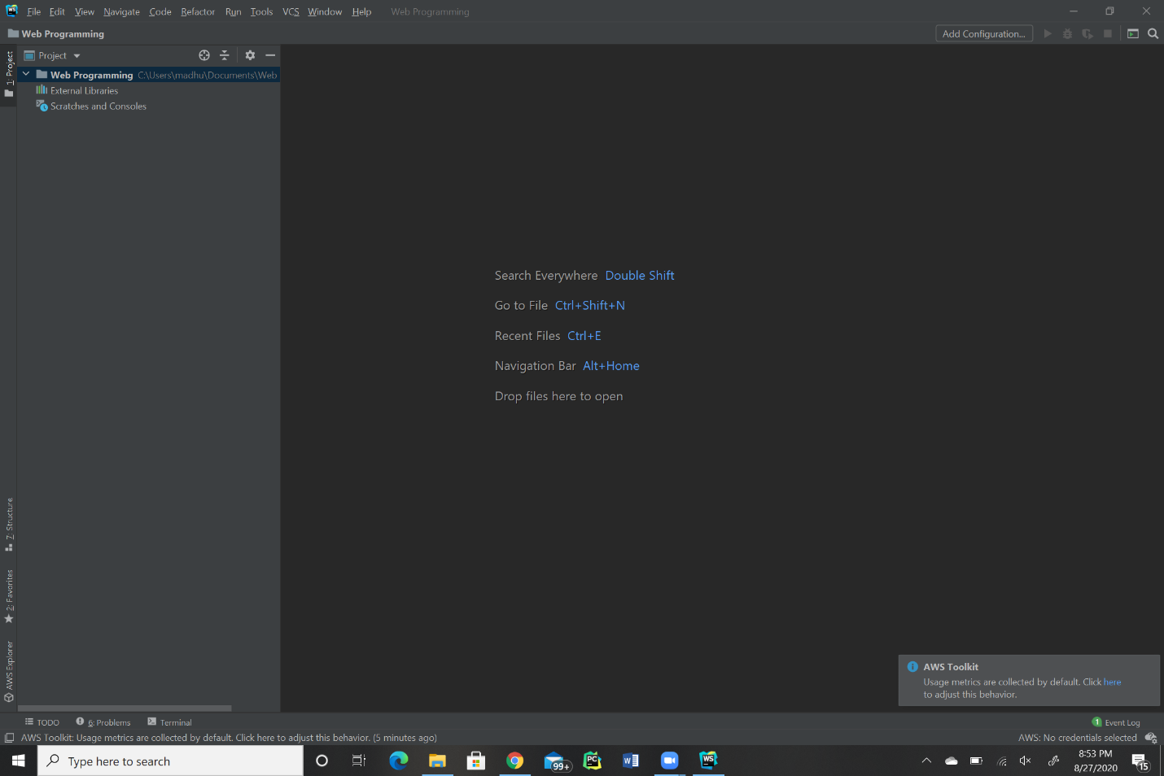

2.created a repository in the github and clone it into the local machine.

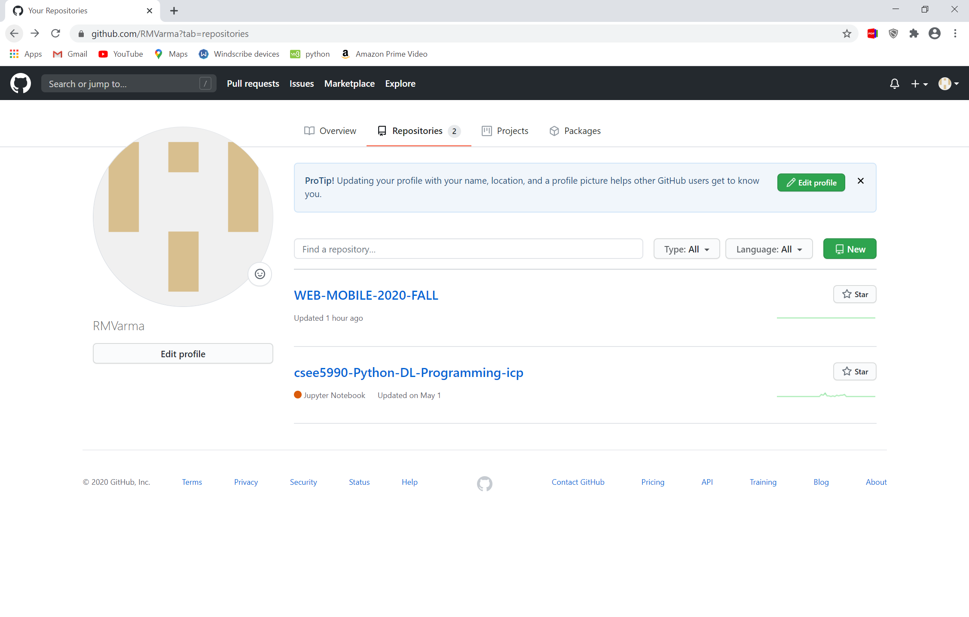

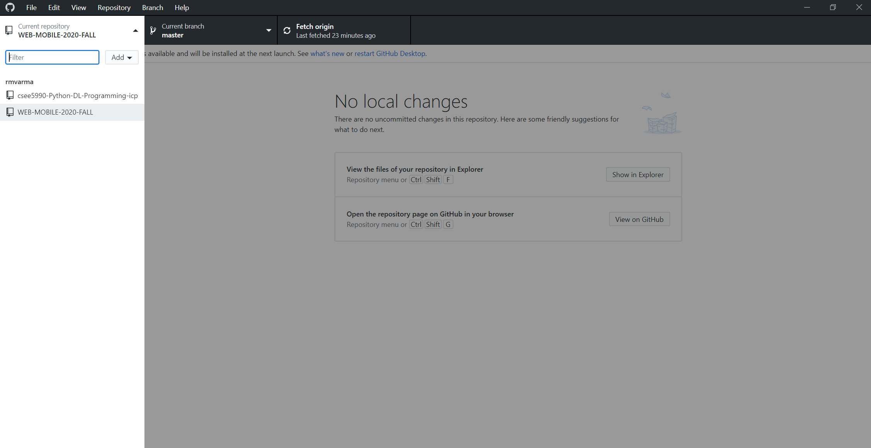

3.Took screenshots and kept it in the documentation folder and synced it in to the remote repository.

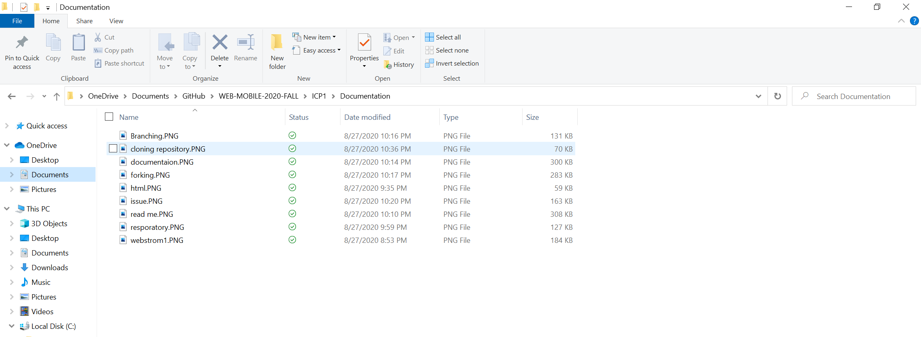

4. Created a html file named HTML.INDEX and placed it in the source code.

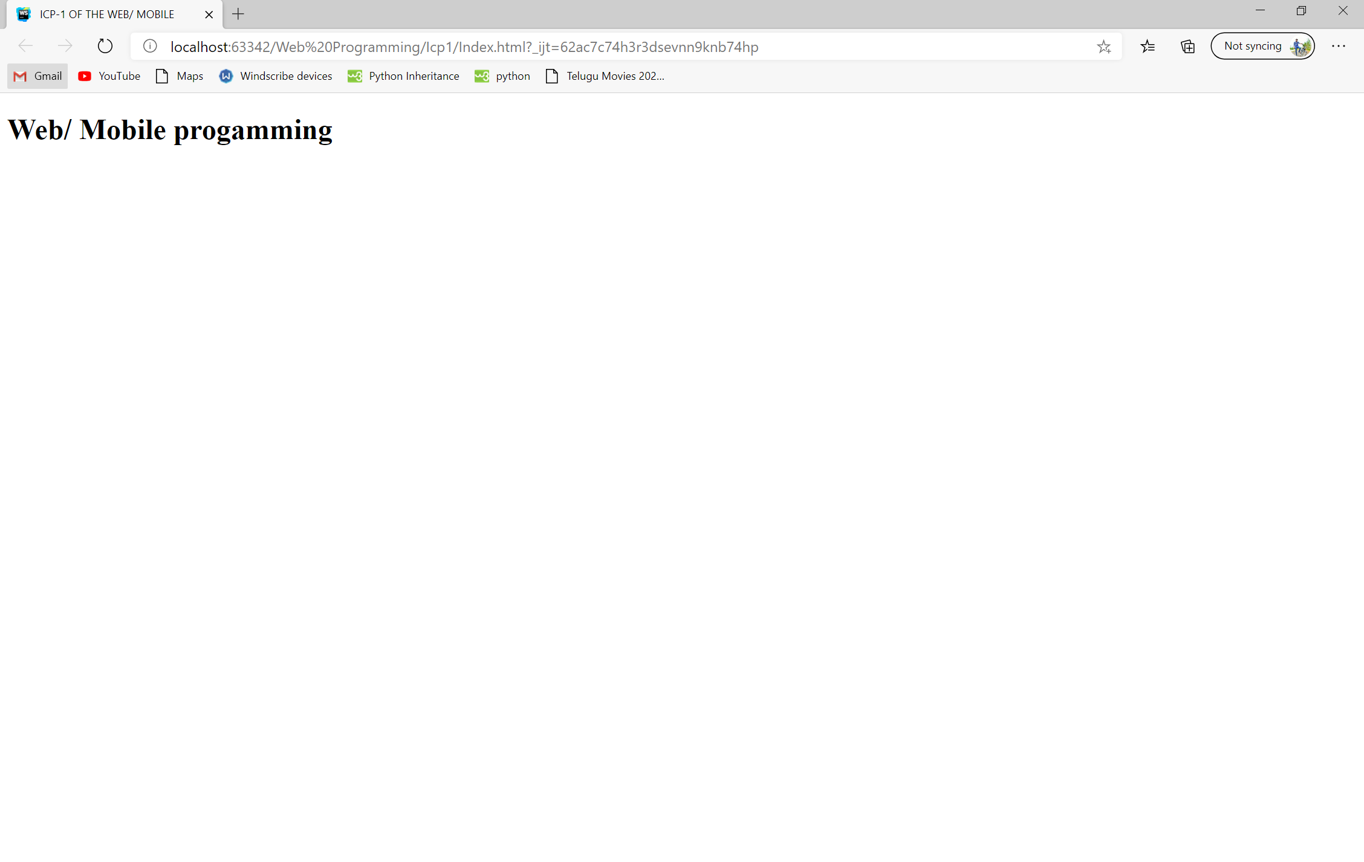

5.wrote about repository in the read.me file.

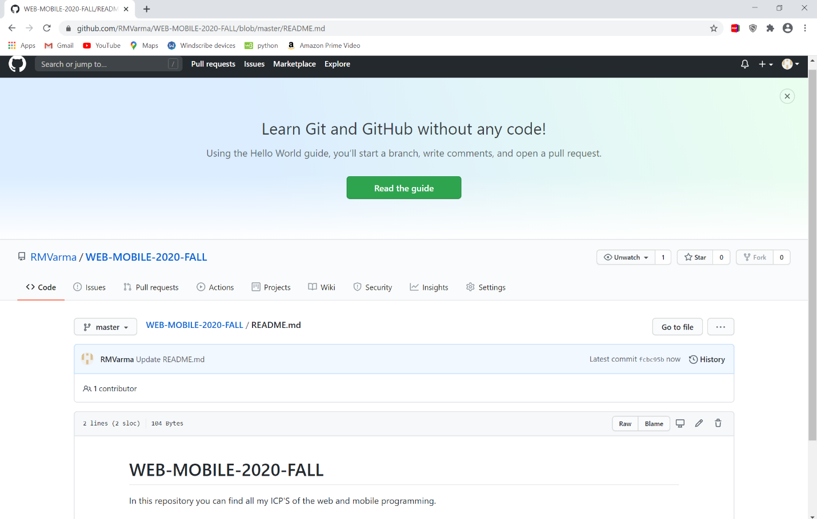

6..Forked the existing repository from the example

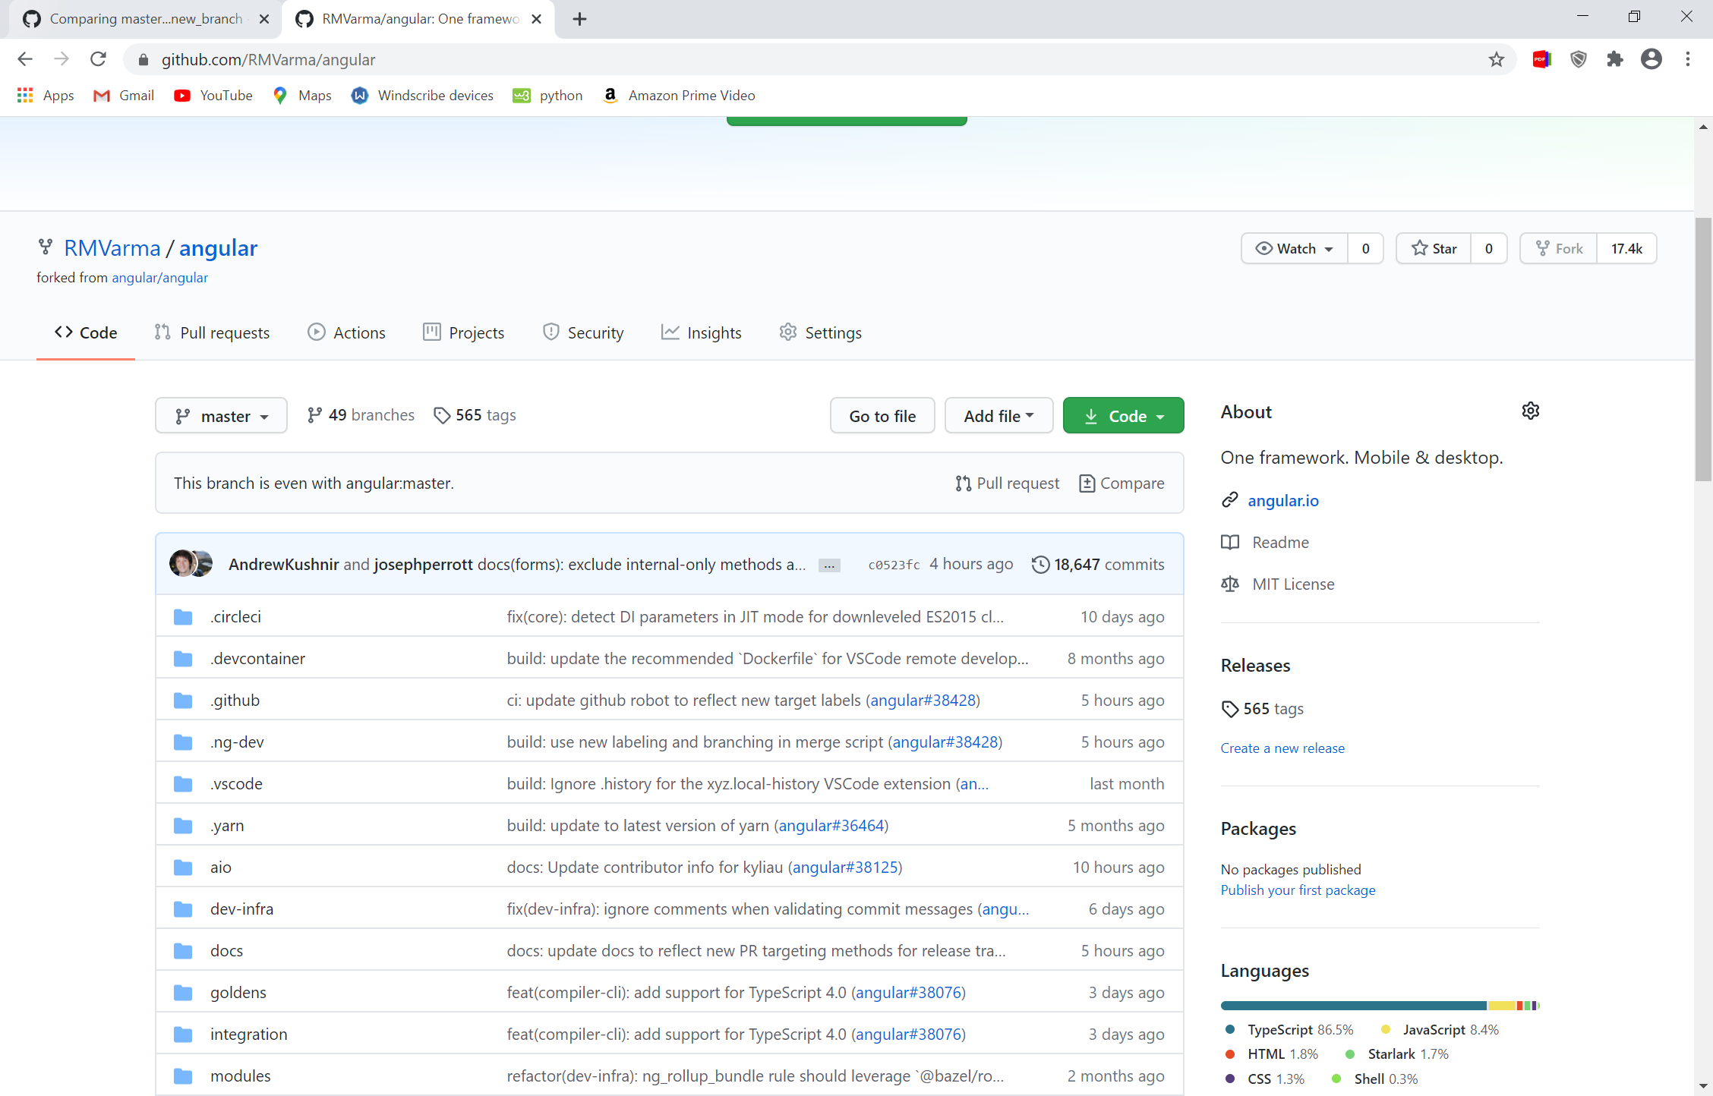

7. Created a branch for my repo and made a pull request.

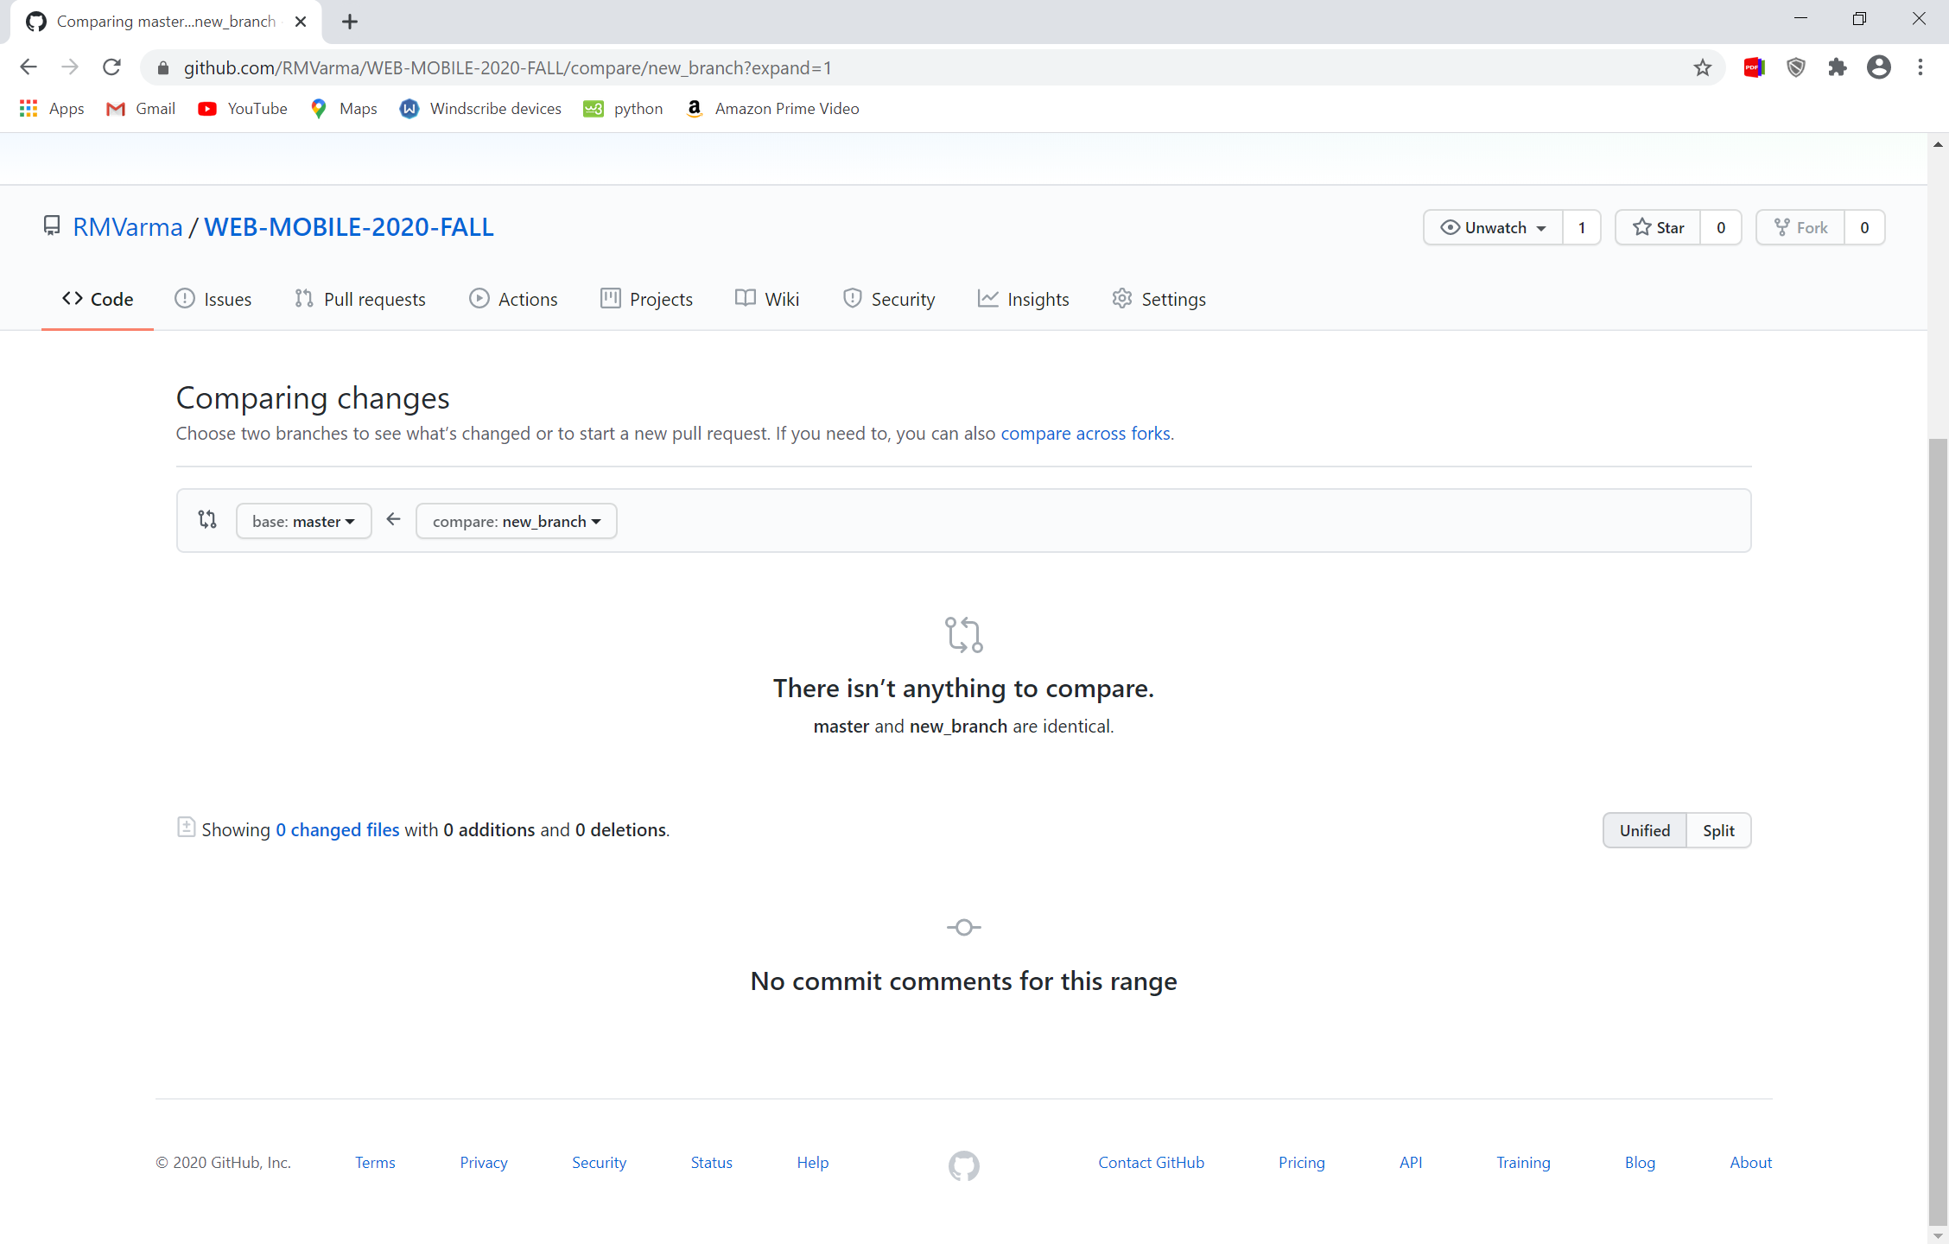

8. created an issue and described new pull request.

